M1.Software

Câu 1:  
Choose the incorrect statement regarding software design principles .

* ① Abstraction refers to reducing a complex system to its core concepts or functions.
* ② Divide and Conquer is the process of extracting modules by organizing the relationships between them into data elements.
* ③ Stepwise Refinement is primarily used in top-down design methods, specifying details for modules step by step.
* ④ Information hiding ensures that other modules cannot directly modify the internal contents and can only exchange information through the interface.

Câu 2:

Select the incorrect statement regarding the data flow diagram below .  
 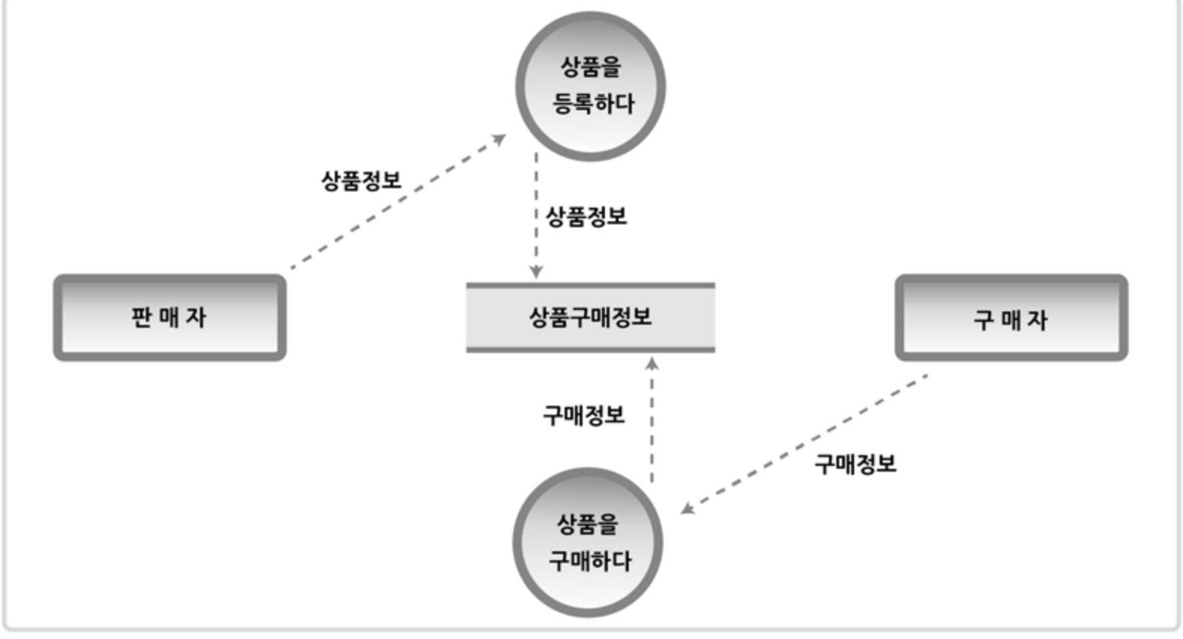

* ① Arrows represent data flow.
* ② The “seller” indicated by the square is the terminator.
* ③ “Product Purchase Information” refers to the data store.
* ④ The use case “purchase a product” is indicated by a circle🡺 sai

Câu 3   
 Select the architecture style applied below .

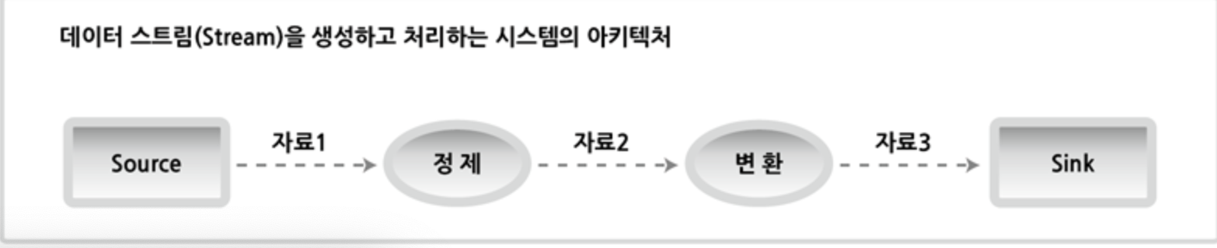

* ① Client server
* ② Layered
* ③ Pipe filter
* ④ Repository

Câu 4   
Select the correct item from the following that is included in the software requirements specification written during the software life cycle (SDLC) analysis phase .

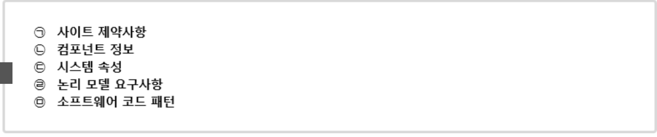

* ① ㉠, ㉡, ㉢
* ② ㉠, ㉢, ㉣
* ③ ㉡, ㉢, ㉤
* ④ ㉡, ㉣, ㉤

Thuộc tính hệ thống là các yêu cầu phi chức năng cần xác định trong bước phân tích

Câu 5

Select the sorting algorithm implemented in the C code below.  
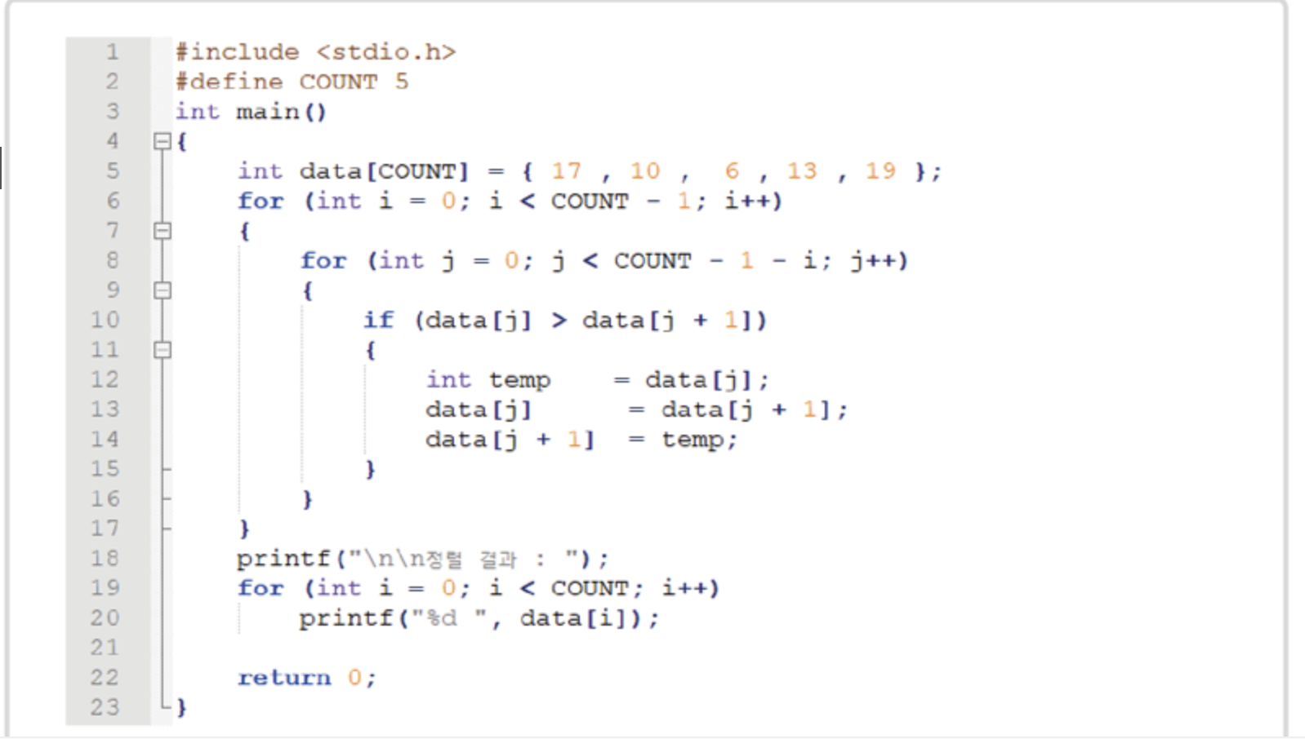

* ①Bubble Sort: so sánh 2 cái liền kề và đổi chỗ
* ②Selection Sort
* ③Insertion Sort
* ④Quick Sort

Câu 6  
 Choose the command described below.

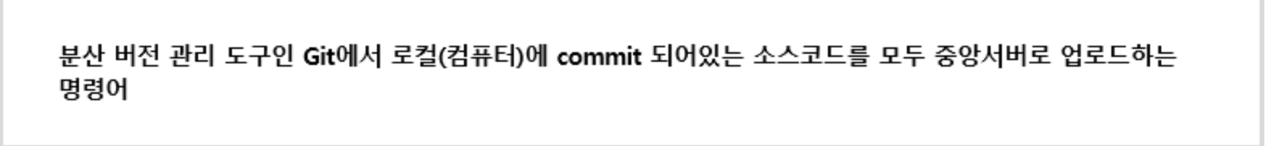

① git save

② git fetch

③ git pull

④ git push

Câu 7   
Select the appropriate code for ㉠ and ㉡ from the 'pseudocode' below that satisfies the 'binary search tree conditions'.  
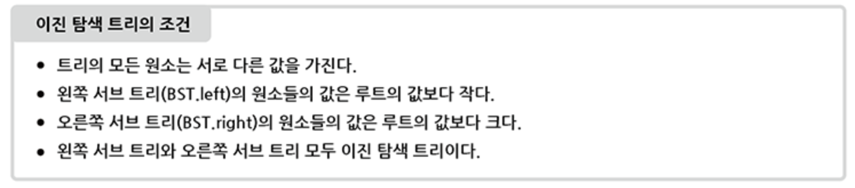

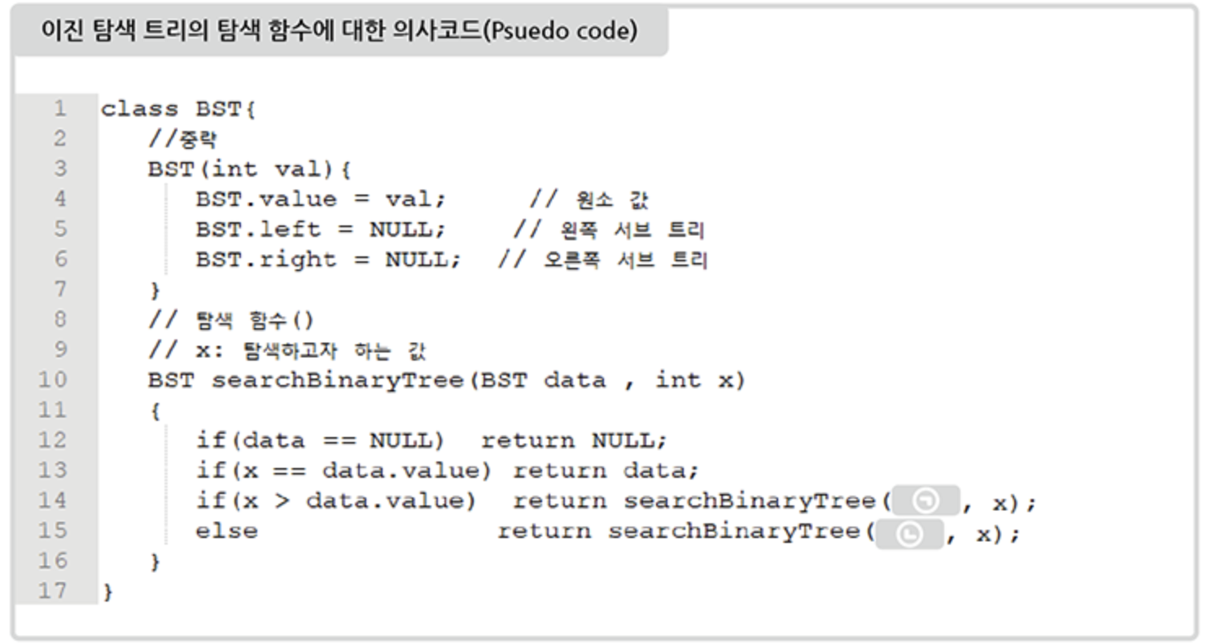

* ① ㉠: data.left, ㉡: data.value
* ② ㉠: data.value, ㉡: data.right
* ③ ㉠: data.left, ㉡: data.right
* ④ ㉠: data.right, ㉡: data.left

Câu 8

Select the design pattern described below.

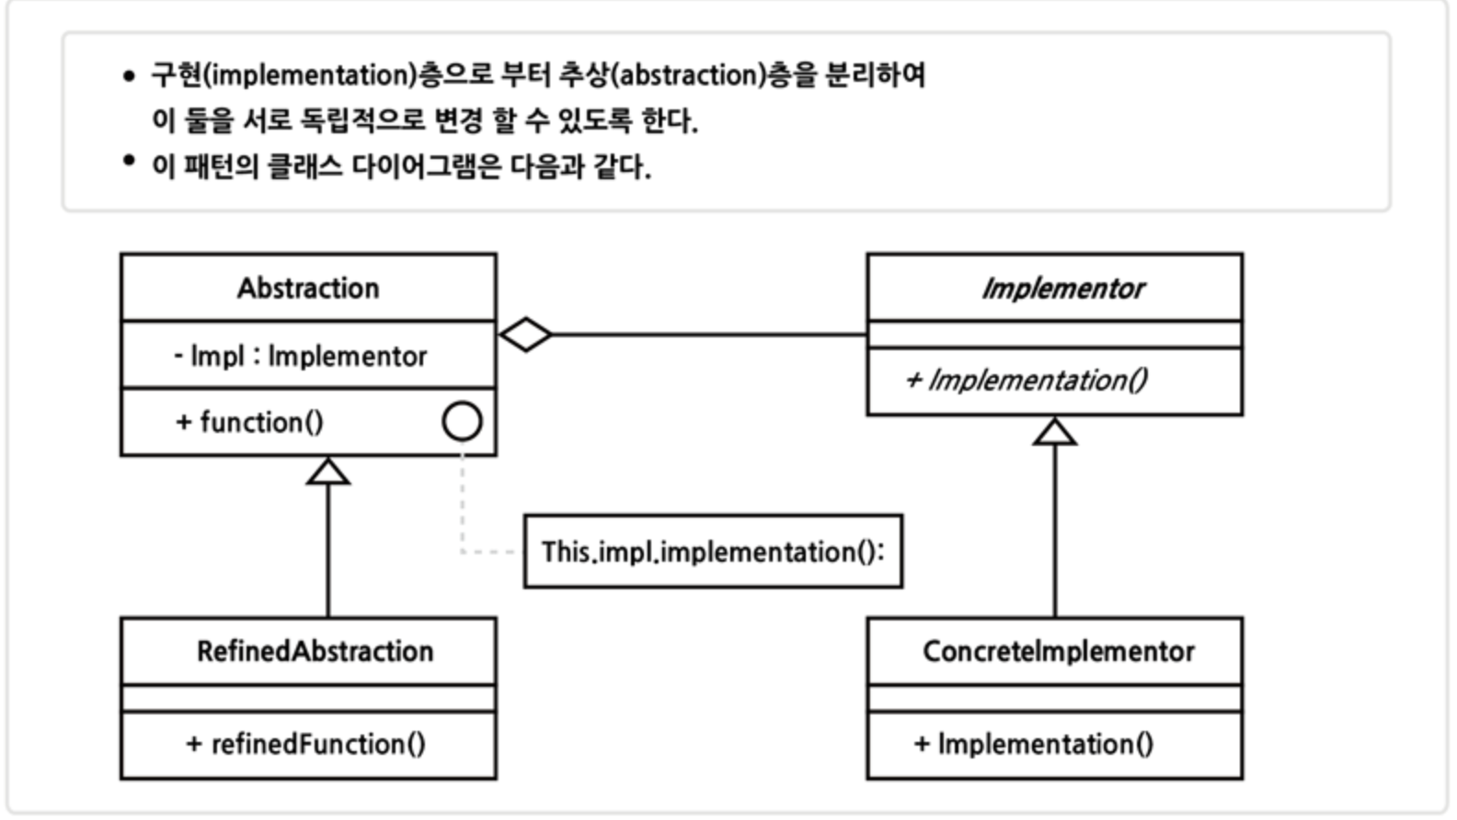

* ① Decorator Pattern
* ② Bridge Pattern
* ③ Adapter Pattern
* ④ Proxy Pattern

Câu 9 Select the data structure that will be common in ㉠.

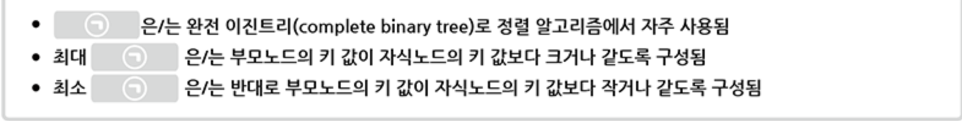

* ① Stack
* ② Linked List
* ③ Queue
* ④ Heap

Câu 10

Select the correct (x,y) value that satisfies the condition coverage of the underlined code below.

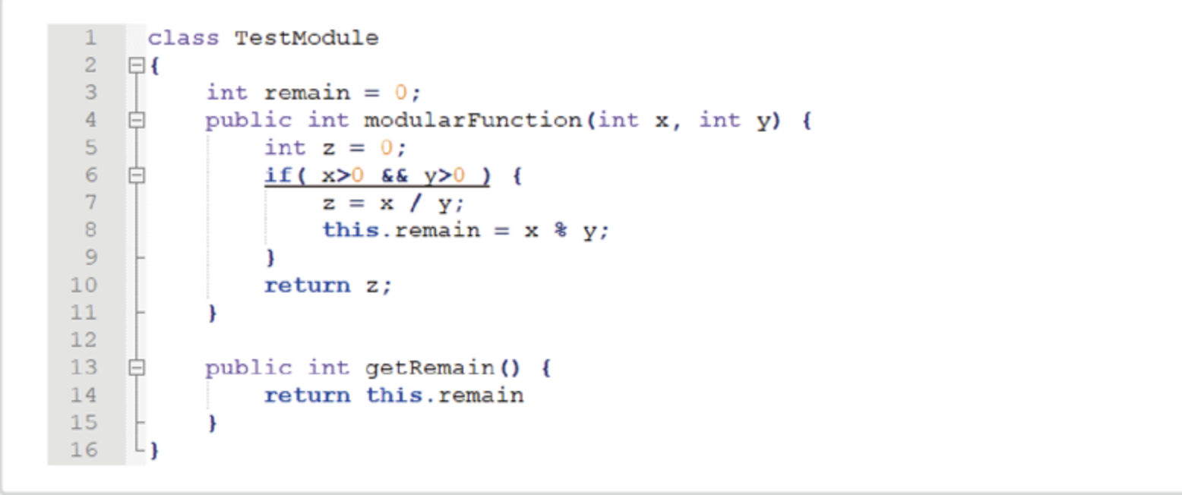

* ① (0, 5) , (0, 0)
* ② (7, 0) , (0, 5)
* ③ (7, 0) , (5, 0)
* ④ (7, 5) , (5, 0)

Câu 11  
 To meet the access restriction requirements below, write the access modifier that will be commonly included in ㉠.

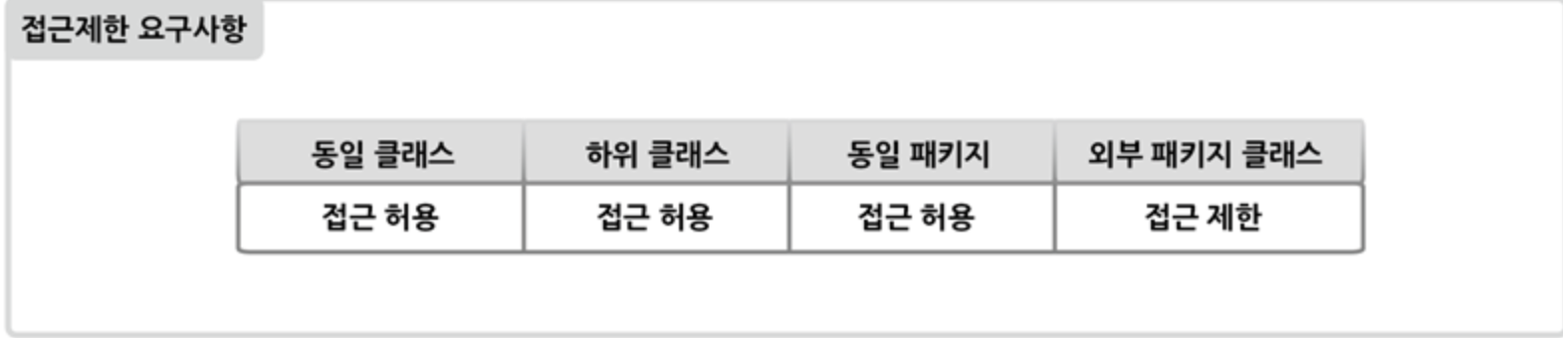

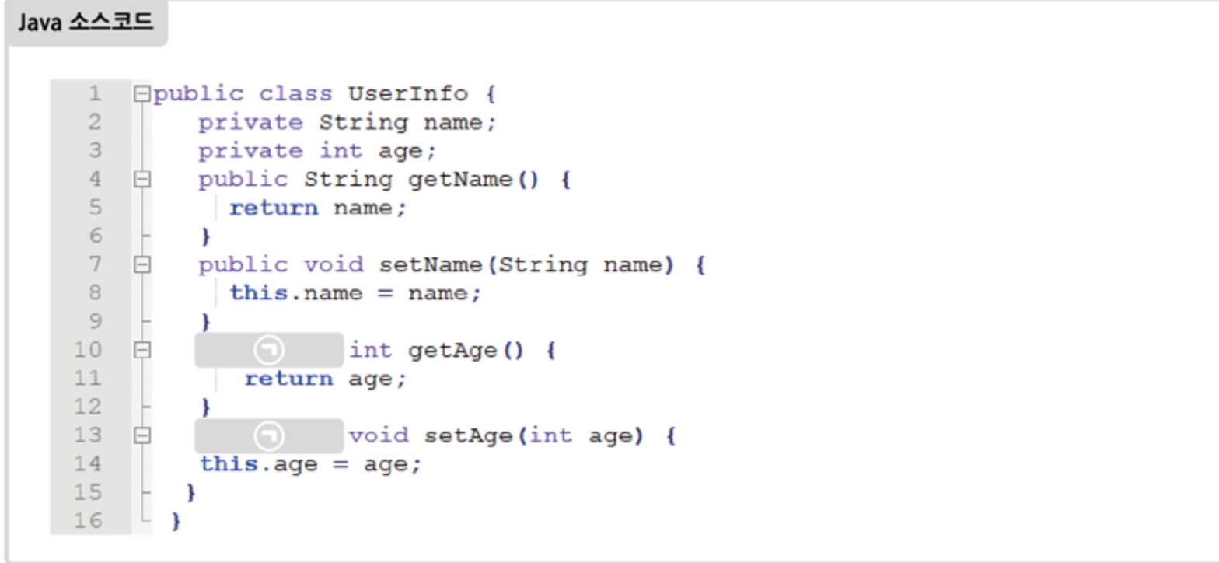

Câu 12

Write the name of the chart described below.

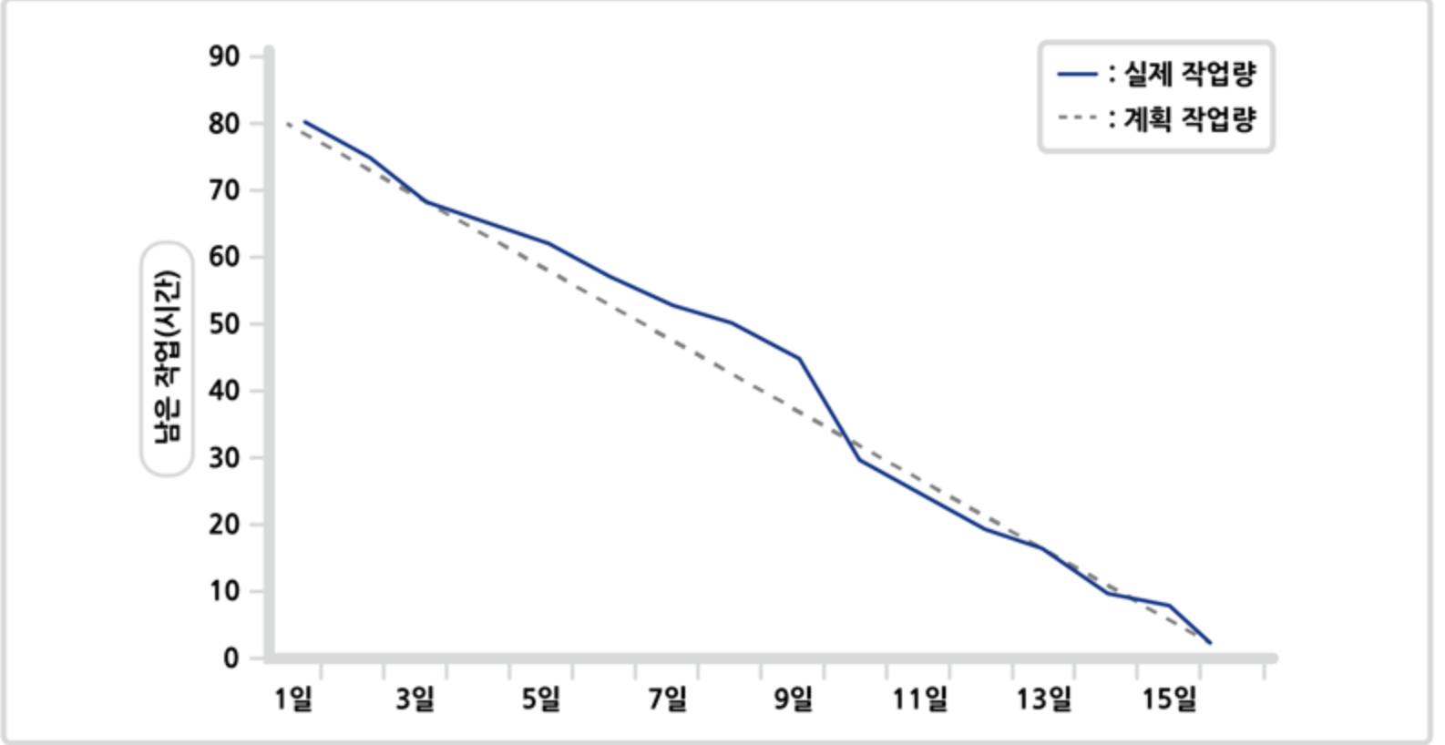

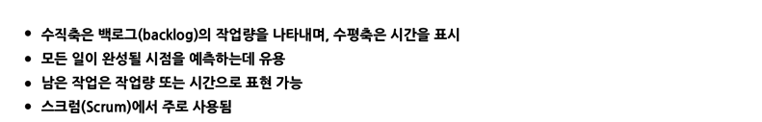

Câu 13

Refer to the Code Smell phenomenon below to answer the questions

(2 subquestions) .

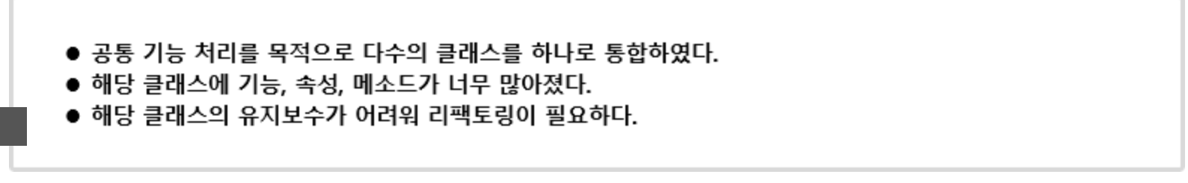

Câu 14

Write HTML codes ㉠, ㉡, ㉢, ㉣ to produce results similar to the screen below. (10 points each)

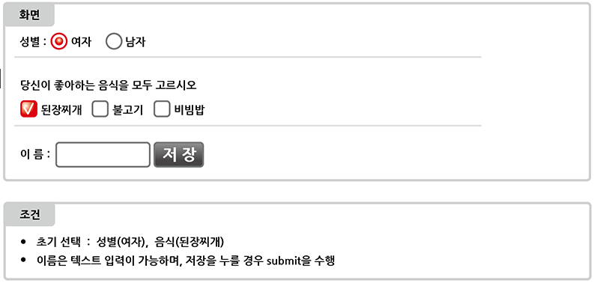

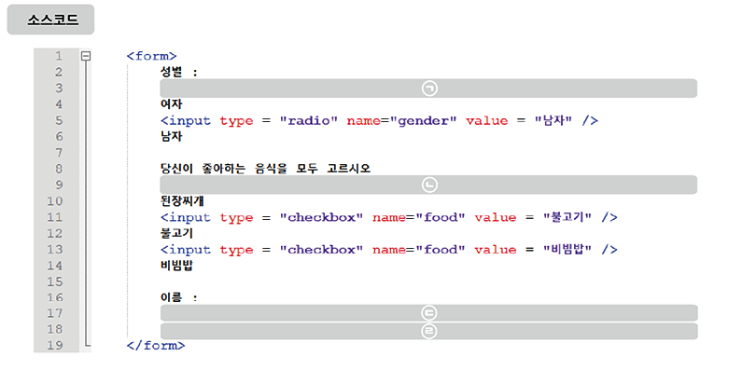

Câu 15   
 Refer to the conditions below and write a Java switch statement in the 'Code Writing' section. 40 points)

(However, write it in a minimal manner without duplicate code.)

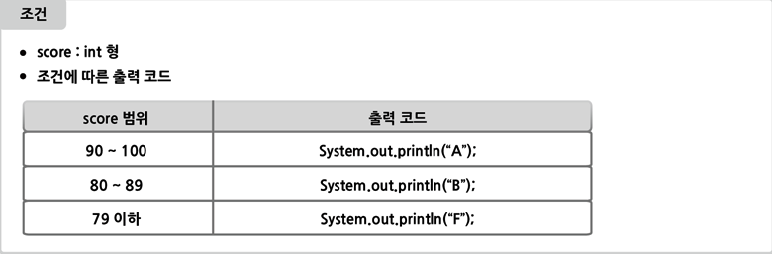

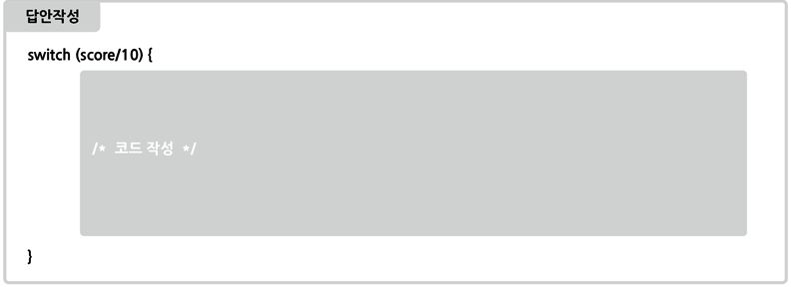

Câu 16

Please answer the questions below using the Java code  
  
 (2 subquestions) .

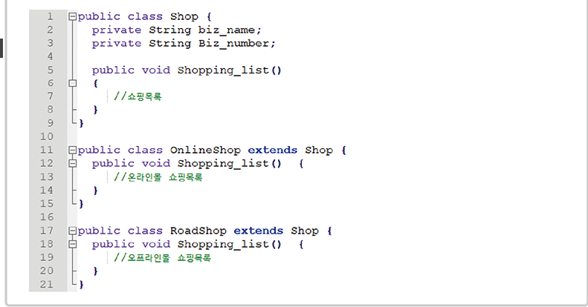

Create a design document for the code below using a tool.

Create a class diagram (30 points).

Question 1) Write the term that corresponds to which of the 3R software reuse techniques the technique used in question 1 corresponds to. (10 points)  
  
Câu 17   
Please answer the questions below

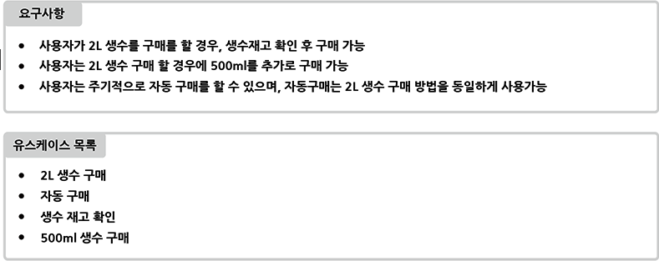

Write the relationship between a use case and another use case. (10 points)

Create a use case diagram by referring to the requirements and use case list. (30 points)

M2.Data

Câu 18

Look below and choose the appropriate functional dependency type for the 'name' property.

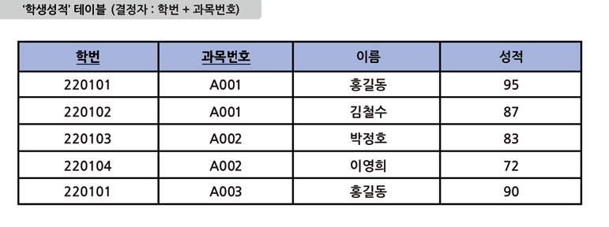

* ① Boyce-codd Functional Dependency
* ② Partial Functional Dependency
* ③ Full Functional Dependency
* ④ Transitive Dependency
* Câu 19
* Select the one that is incorrect in its description and representation of the entity-relationship model .
* (However, Crow's Foot notation is used.)
* 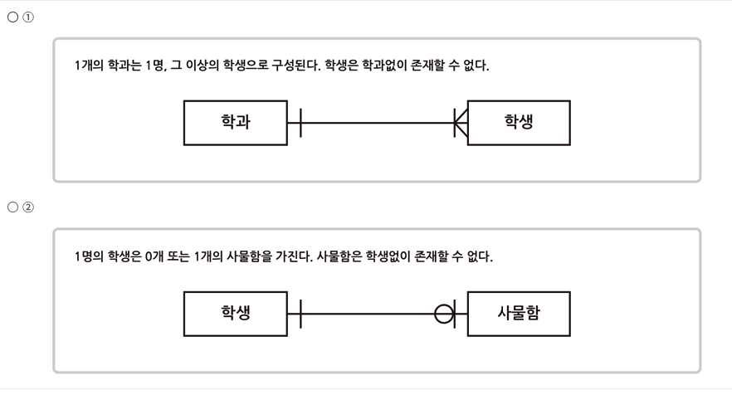
* 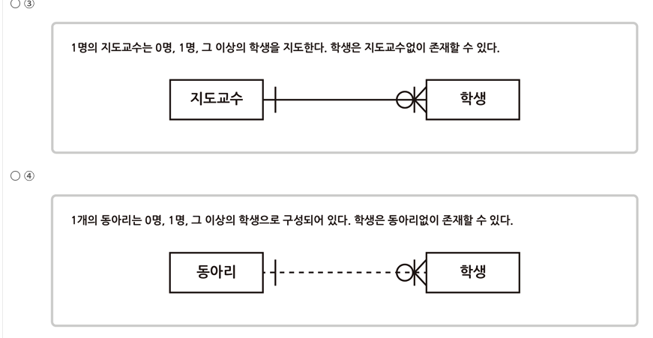

Câu 20   
To ensure serializability with the 2-phase locking (2PL) protocol below:

Select the command to enter in ㉠.

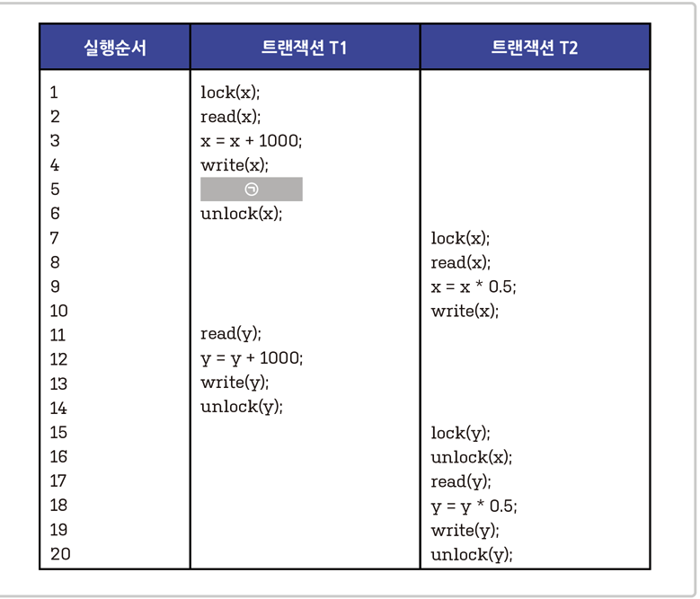

* ① lock(x)
* ② lock(y)
* ③ read(x)
* ④ unlock(y)

Câu 21

Select the appropriate task performed in the concept modeling phase from the following.

* ①Perform normalization.
* ②Define the subject area.
* ③Derive an Entity Relationship Diagram.
* ④Define attributes and determine identifiers.

Câu 22   
Select the appropriate data mining technique to apply to the case below.

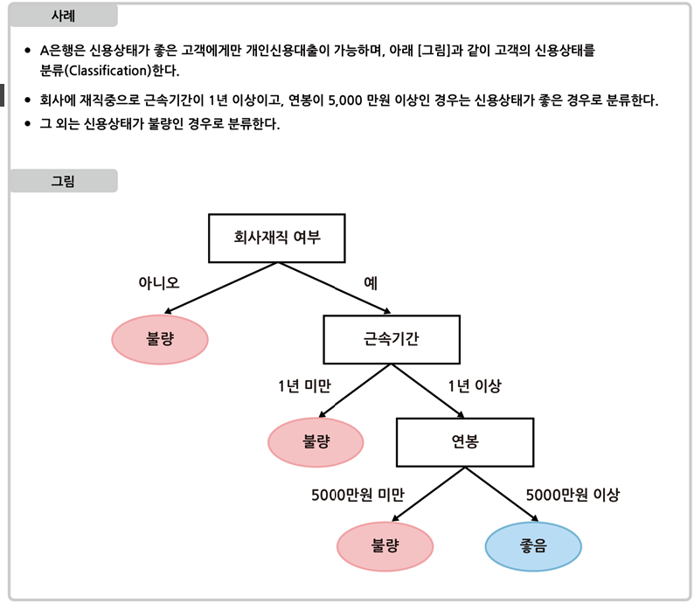

* ① Co-Occurrence Matrix
* ② Decision Tree
* ③ Convolutional Neural Network
* ④ K-Nearest Neighbor Algorithm

Câu 23   
 Look at the ‘Query Content’ below and write the SQL operator that goes in ㉠.

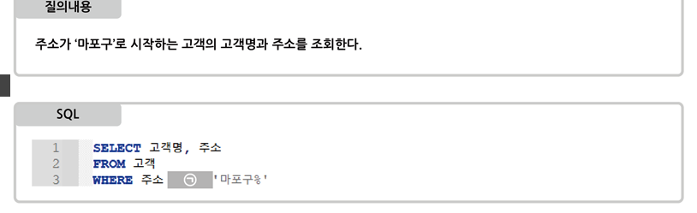

Câu 24   
 Please answer the questions below.

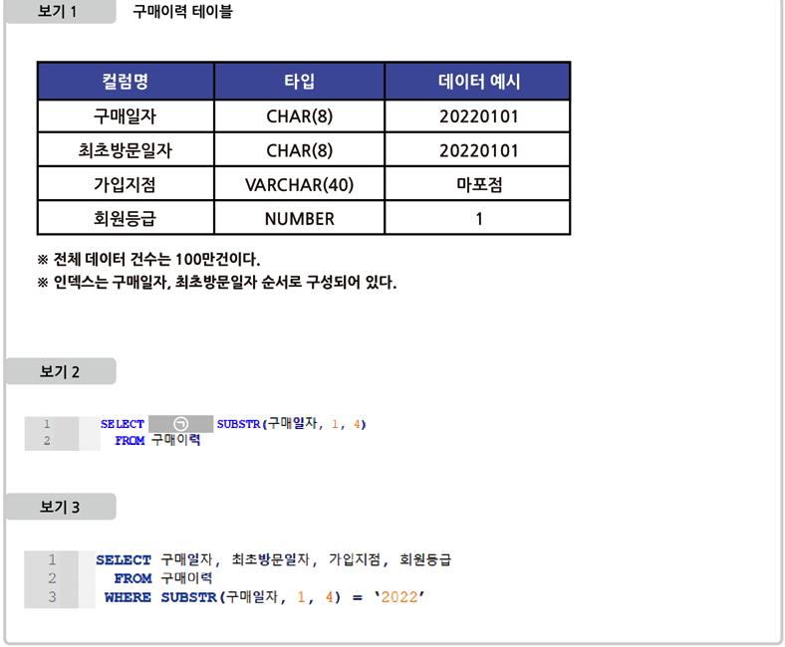

1. To search for purchase years without duplication, an SQL statement was written as in ‘Example 2’.

Refer to 'Example 1' and write the operator (or command) to be included in part ㉠. (10 points)

2. I executed the SQL statement in 'View 3' to check the purchase history for '2022', but I could not use the index range scan.

Analyze the SQL statement and explain the reason. (20 points)

Câu 25

Refer to 'Option 1' and 'Option 2' below and write ㉠, ㉡, ㉢, and ㉣ in 'Option 3' in order. (10 points each, total 40 points)

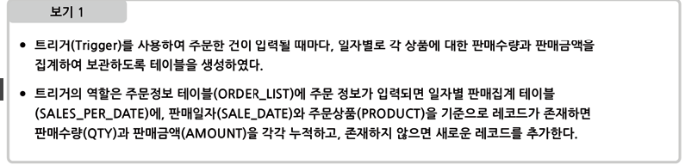

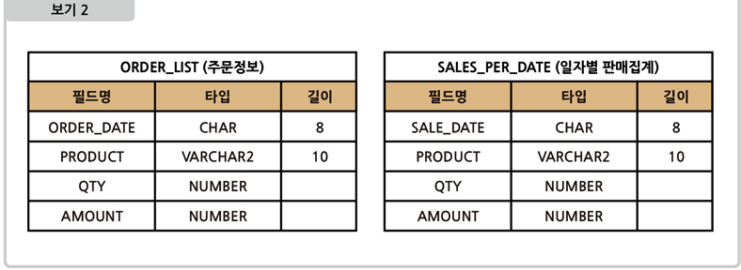

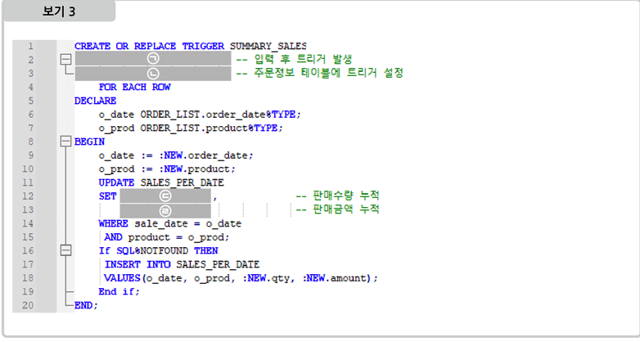

Câu 26   
Please answer the questions below.

(2 subproblems)

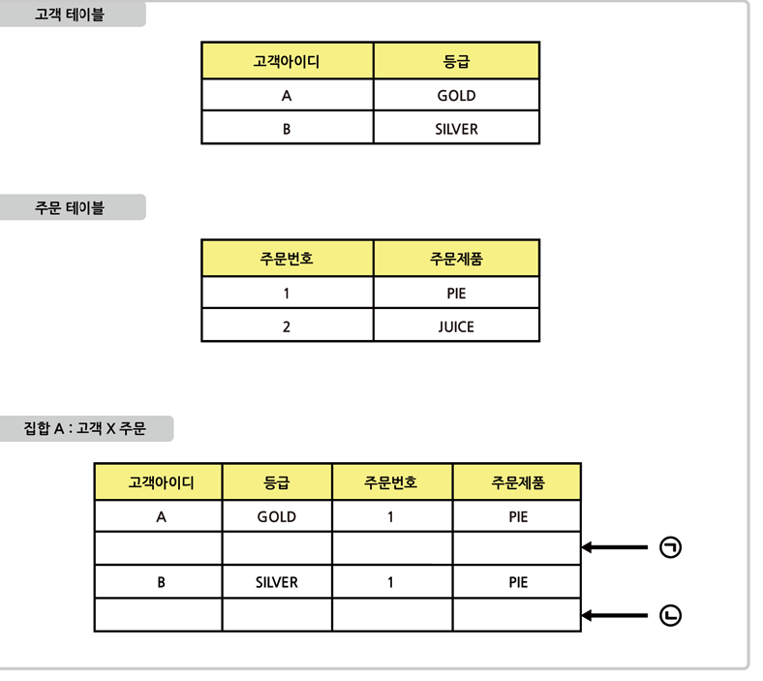

1. Cartesian Product operation of relational algebra satisfies 'customer X order'

Write tuples ㉠ and ㉡ of set A. (10 points each, total 20 points)

(※ Writing example - ㉠: A, GOLD, 1, PIE)

1. Write a SQL statement to retrieve the results of the 'Customer X Order' set in Problem 1). (20 points)

M3. System Artchitecture

Câu 27

Below is the system bus structure of a computer. Choose what ㉠ is.  
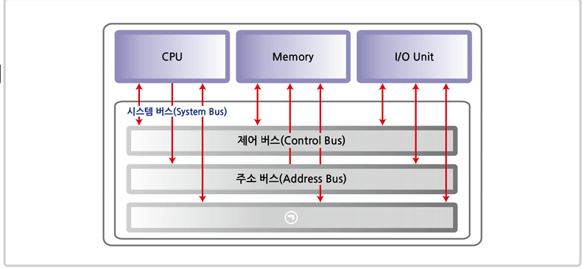

* ①
* I/O bus (Input/Output Bus)
* ②
* Data Bus
* ③
* Channel Bus
* ④
* Direct Memory Access Bus (DMA Bus)

Câu 28   
Select the network error control method described below.

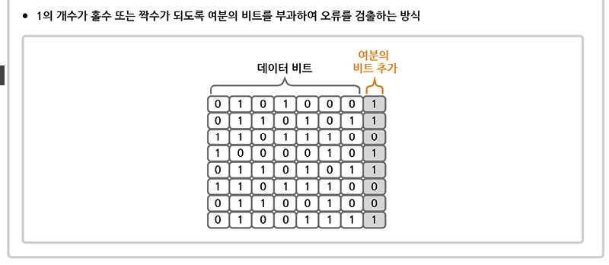

* ①
* Cyclic Redundancy Check (CRC)
* ②
* Echo Check
* ③
* Parity Check
* ④
* Hamming Code

Câu 29   
Which deployment method is mainly used in Kubernetes

? Select the deployment method described below.

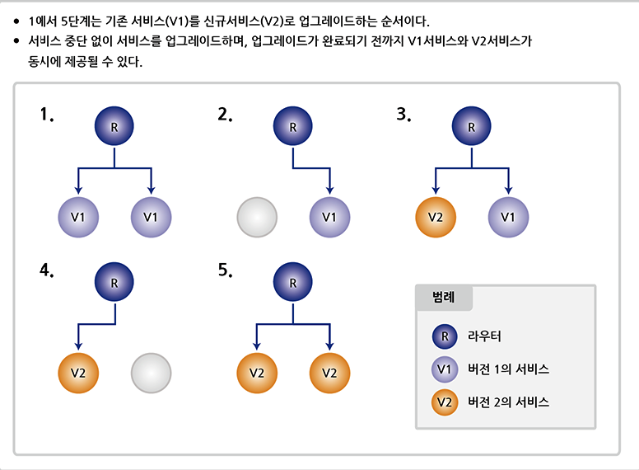

* ①
* Rolling Deployments: triển khai trên từng nhóm nhỏ trước
* ②
* Blue-Green Deployments
* ③
* Big Bang Deployments: cập nhạt trên tất cả máy chủ cùng lúc
* ④
* Canary Deployments: giống rolling nhưng có thêm phần nghe ngóng xem có lỗi không

Câu 30   
Select the incorrect description of paging, one of the virtual memory allocation techniques .

* ①
* External fragmentation may occur.
* ②
* The physical address space is divided into equal-sized parts and used.
* ③
* Links logical addresses and physical addresses through page tables.
* ④
* Process data is cut into pages of a certain size and loaded into memory.

Câu 31   
Choose the incorrect description of DNS (Domain Name System) among the following .

* ①
* Specifying multiple IP addresses for a single domain is not allowed.
* ②
* It is a protocol belonging to the application layer of the OSI 7 Layer.
* ③
* Convert domain to IP or IP to domain.
* ④
* If your domain name is complex, you can use an alias.

Câu 32   
In the web service architecture below, write which server ㉠ is.

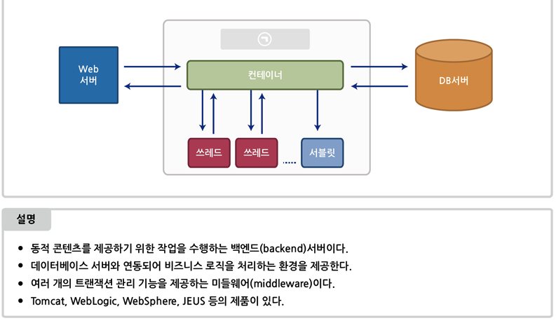

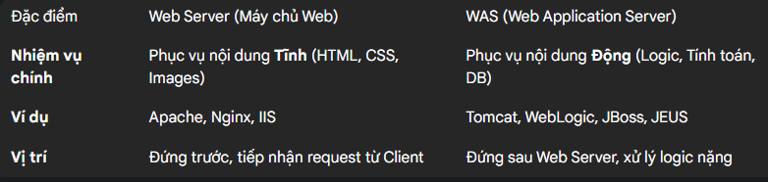

Câu 33   
Looking at the network status of Company A below, we would like to subnet the network addresses used by the project team and research institute.

㉠ Write the subnet mask value that will be commonly entered.

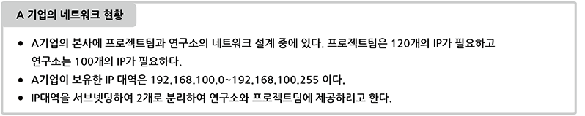

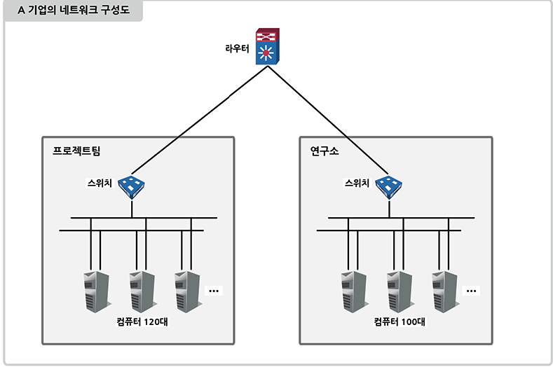

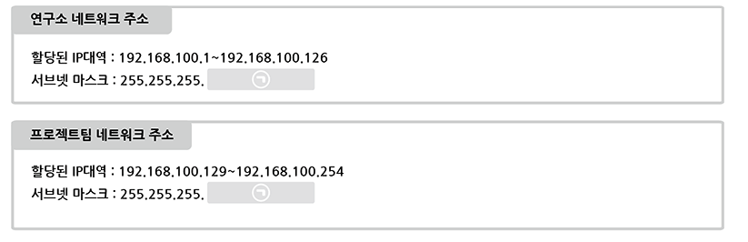

Câu 34   
To respond nimbly to business changes, Company A is adopting a microservices architecture and

plans to build a Docker-based deployment system, as shown below.

Answer the questions

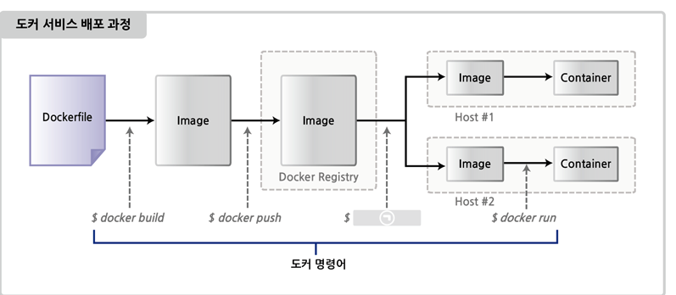

Explain the concept of Docker. (10 points)

Write the Docker command that will be used in ㉠ during the Docker service deployment process (10 points) and explain what is performed (10 points) (Total 20 points)

M4. Infromation Security

Câu 35   
Company A, which operates an Internet shopping mall, follows the personal information processing policy posted on its website.

We are reviewing the appropriateness of the membership registration page.

Select the incorrect collection standard for personal information processing based on relevant laws .

① Collection of the minimum necessary personal information

② Distinction between required and optional consent items

③ Collect personal information when necessary

④ Encryption of collected personal information

Câu 36

Select the unknown item from the description below .

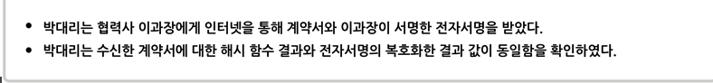

* ① The contract received was not forged or altered.
* ② We guarantee that the contract is a document written by Manager Lee.
* ③ The contract was not leaked externally during the transmission and reception process.
* ④ A pair of private and public keys was used.

Câu 37

Which of the following is not a correct setting for Windows system security ?

* ① Delete unnecessary Guest accounts.
* ② Block access to shared folders and remote registry.
* ③ Use iptables to block network access.
* ④ Stop unnecessary services such as terminal services, anonymous FTP, and SNMP.

Câu 38   
Select the user authentication technology described below.

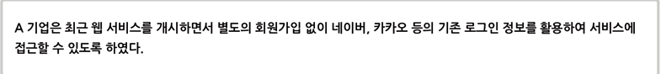

* ① OAuth (Open Authorization)
* ② OTP (One Time Password)
* ③ Public Key Infrastructure (PKI)
* ④ SSL (Secure Socket Layer)

Câu 39   
Which of the following statements is incorrect regarding Log4j vulnerabilities ?

* ① Depending on your Java version, you need to update Log4j to the latest version.
* ② DDoS and malware attacks are possible by exploiting Log4j vulnerabilities.
* ③ It was rated as Critical in the Common Vulnerability Scoring System (CVSS).
* ④ This occurs when the return value is not verified when calling the JNDI Lookup Method.

Câu 40   
Write the term that goes in the blank below.

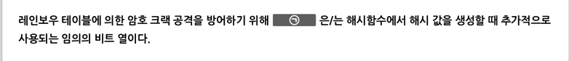

Câu 41   
Write the names of the security threats described below.

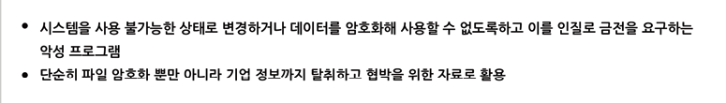

Câu 42

Below is the source code written in C language in a Linux environment.

Answer the questions.

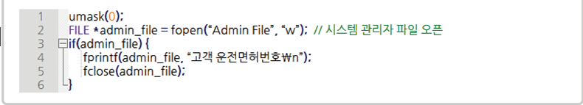

Write down the unsafe line number (10 points) and explain why (10 points). (Total 20 points)

Modify the source code of Problem 1) to a safe code. (20 points)

M5.IT Bussiness and Ethics

Câu 43

Choose an artificial intelligence framework described below.

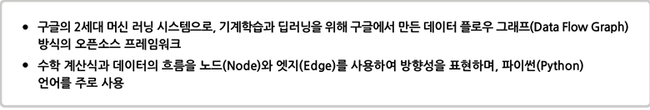

* ① Keras
* ② Theano
* ③ TensorFlow
* ④ PyTorch

Câu 44

In the situation below, choose the most appropriate action for the manager.

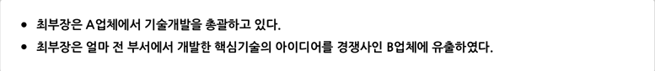

* ① Personal information leak
* ② unfair competition
* ③ Copyright infringement
* ④ Violation of professional ethics

Câu 45

Among the following, PEST (Political, Economic, Social, Technological) is a macro-environmental analysis method.

Choose the incorrect analysis for each element .

①

* Political – We investigated changes in the laws, compliance, and political environment related to the service.
* ②
* Economic – We investigated the target market's growth rate, inflation and interest rates, labor costs, etc.
* ③
* Social – We investigated air, water, and soil pollution that may occur from services.
* ④
* Technological Environment – ​​We investigated changes in the technological environment, the impact of new technologies, research and development activities, and the effects of technology transfer.

Câu 46

Select the incorrect connection between BSC (Balanced Score Card) and IT-BSC .

* ①
* Customer Perspective - User Perspective
* ②
* Internal Process Perspective - Information Technology Perspective
* ③
* Financial Perspective - Contribution to the Company Perspective
* ④
* Learning and Growth Perspective - A Forward-Looking Perspective

Câu 47   
Among the following, in the 'Artificial Intelligence (AI) Ethics Standards' announced by the South Korean government in December 2020:

Select the basic principle that applies below.

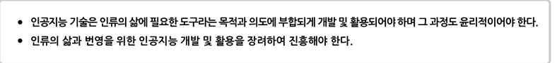

* ①
* The principle of technical fitness for purpose
* ②
* The principle of public good in society
* ③
* Principle of Human Dignity
* ④
* Principles of Privacy Protection

Câu 48   
Choose the web technology described below.

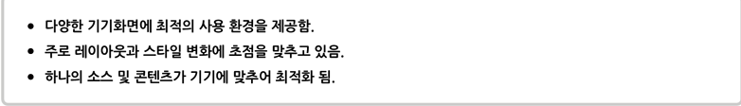

* ①
* Dark Web
* ②
* Responsive Web
* ③
* Social Web
* ④
* Semantic Web

Câu 49

Select the term that refers to section ㉠ in the 'Technology Adoption Lifecycle' diagram below.

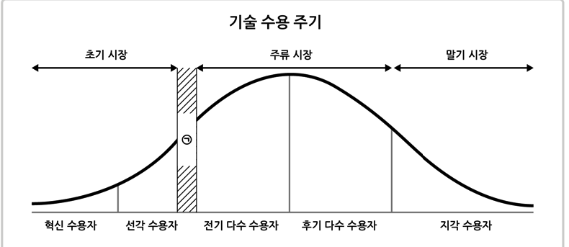

* ①
* Main street
* ②
* Bowling alley
* ③
* Tornado
* ④
* Chasm

Câu 50   
Write down the terms for the problem-solving techniques described below.

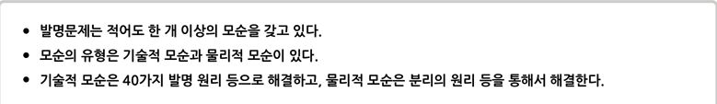

Câu 51  
Write the name of the personal information de-identification technique described below.

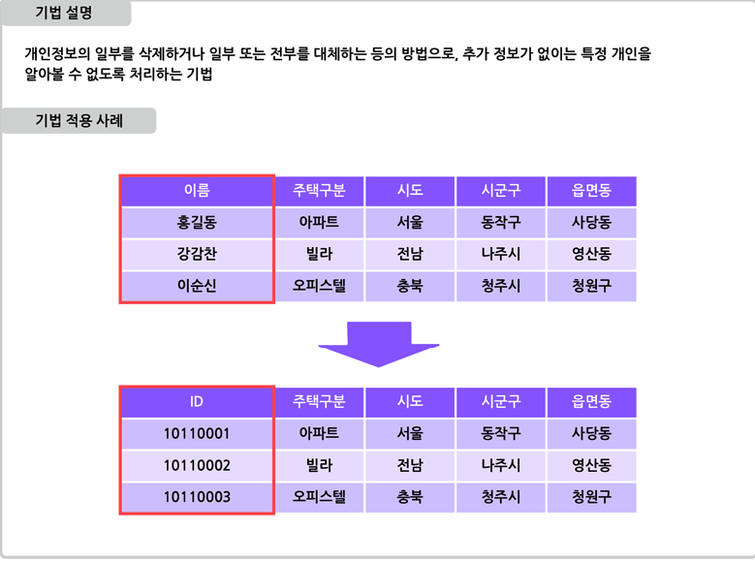

Câu 52

Write the term that goes in ㉠ in the table below.

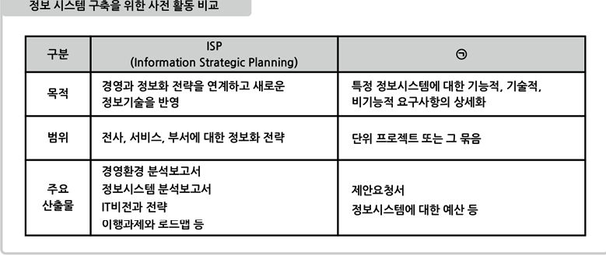

Câu 53   
Please answer the questions below.

(2 subproblems)

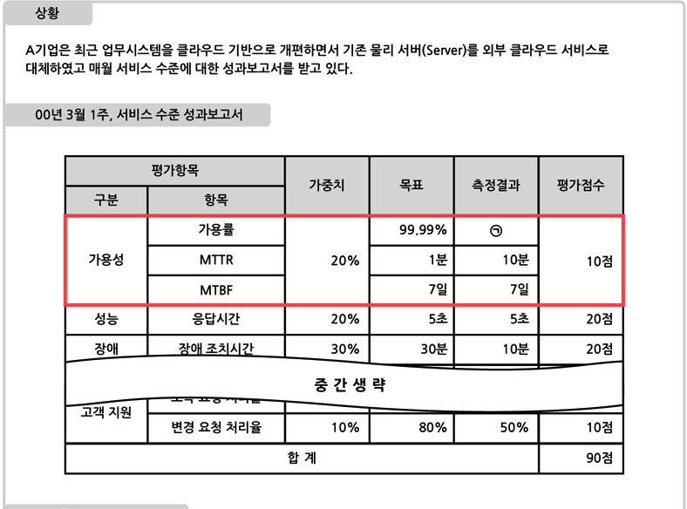

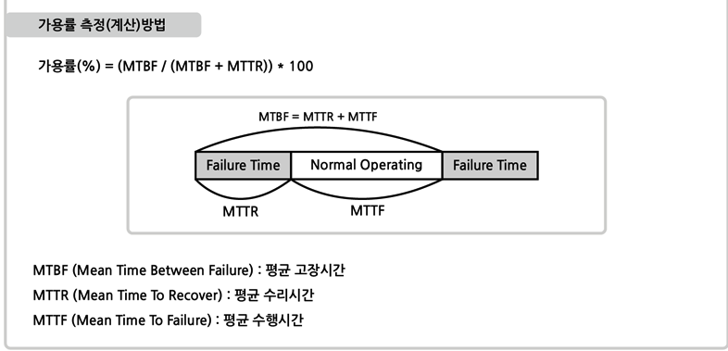

Write the name of the agreement that includes service objectives and measurement indicators between Company A, the service user, and the service provider. (10 points)

Refer to the 'Service Level Performance Report' to find the availability rate for ㉠. (20 points)

(※ However, the calculation results are rounded to the third decimal place)

M6. TC and PM

Câu 54

Select the project management area described below.

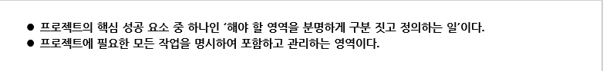

* ①
* Scope Management
* ②
* Schedule Management
* ③
* Resource Management
* ④
* Quality Control

Câu 55   
Select the incorrect description of quality control techniques below .

* ①
* A cause and effect diagram analyzes how causes and effects are related.
* ②
* The Pareto chart analyzes and controls problems in order of impact to determine problem priorities.
* ③
* A scatter diagram is a tool used to visually represent the relationship between two or more variables.
* ④
* The control chart sets the upper and lower limits of the quality target value as control limits, and if these are exceeded, it is judged to be in an unstable state.

Câu 56   
 Select the risk response strategy used by Company A below.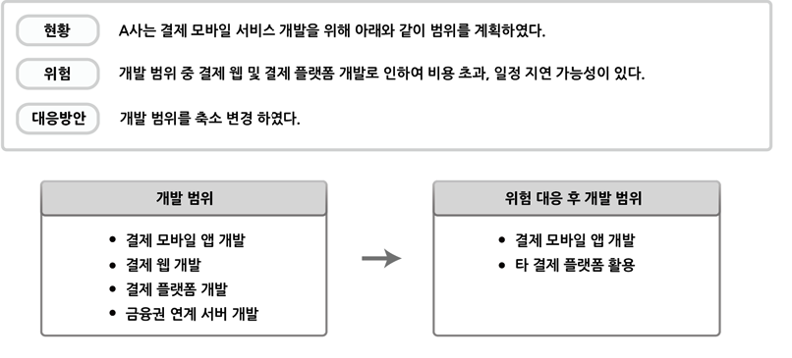

* ①
* Avoid
* ②
* Acceptance
* ③
* Transfer
* ④
* Share

Câu 57   
Select the chart described below.

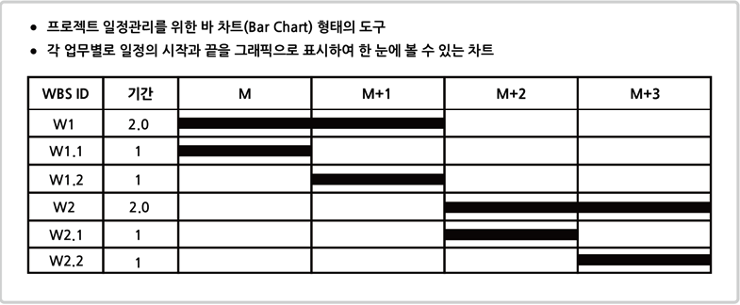

* ①
* Candle Chart
* ②
* Gantt Chart
* ③
* Pareto Chart
* ④
* PERT(Performance Evaluation and Review Technique) Chart

Câu 58   
To restructure its security product portfolio, Company K created the Boston Consulting Group (BCG) matrix below.

Based on this, select the strategy that best describes Company K's strategy.

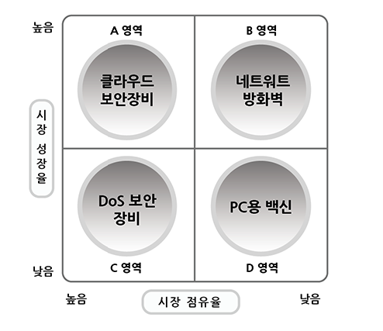

* ①
* PC antivirus software will cease operations in the market and withdraw from the D sector.
* ②
* Cloud security equipment is stopped from being invested and is kept in Area A.
* ③
* Network firewalls are maintained at current investment levels and remain in Zone B.
* ④
* DoS (Denial of Service) security equipment is expanding new investments and moving to Area A.

Câu 59

Select the correct calculation of the project cost estimate below using the three-point estimation method.

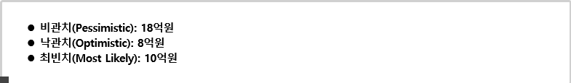

Câu 60   
In Scrum, one of the Agile methodologies,

write the appropriate term that is commonly used in the ㉠ section, which refers to the development cycle with the following characteristics.

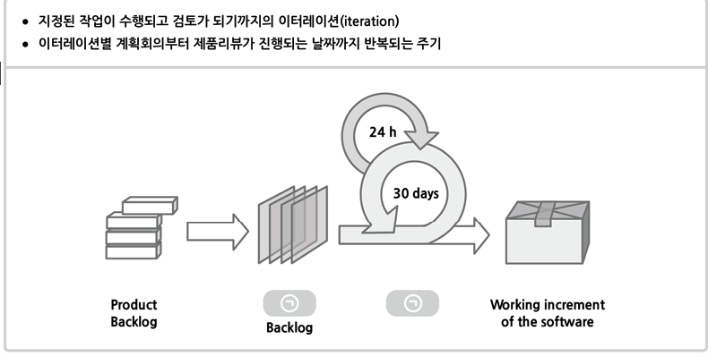

Câu 61   
Write the name of the document that corresponds to the description and case below.

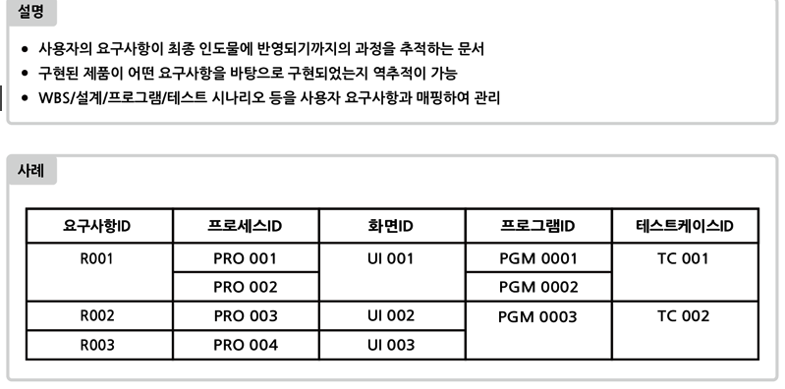

Câu 62   
Please answer the questions below

(2 subquestions)

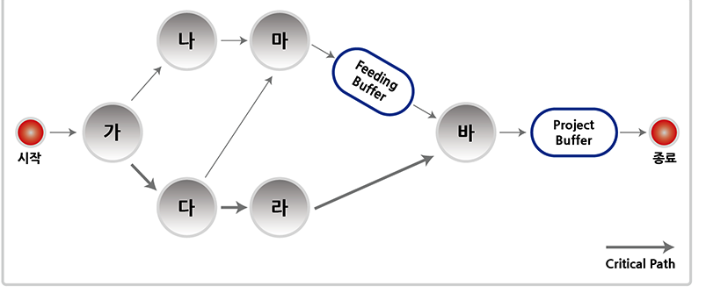

Describe a scheduling technique that creates a buffer along the project schedule path, taking into account limited resources and project uncertainty . (10 points)

Explain the role of the Project Buffer. (20 points)